George Davidson (1887 – 1938)
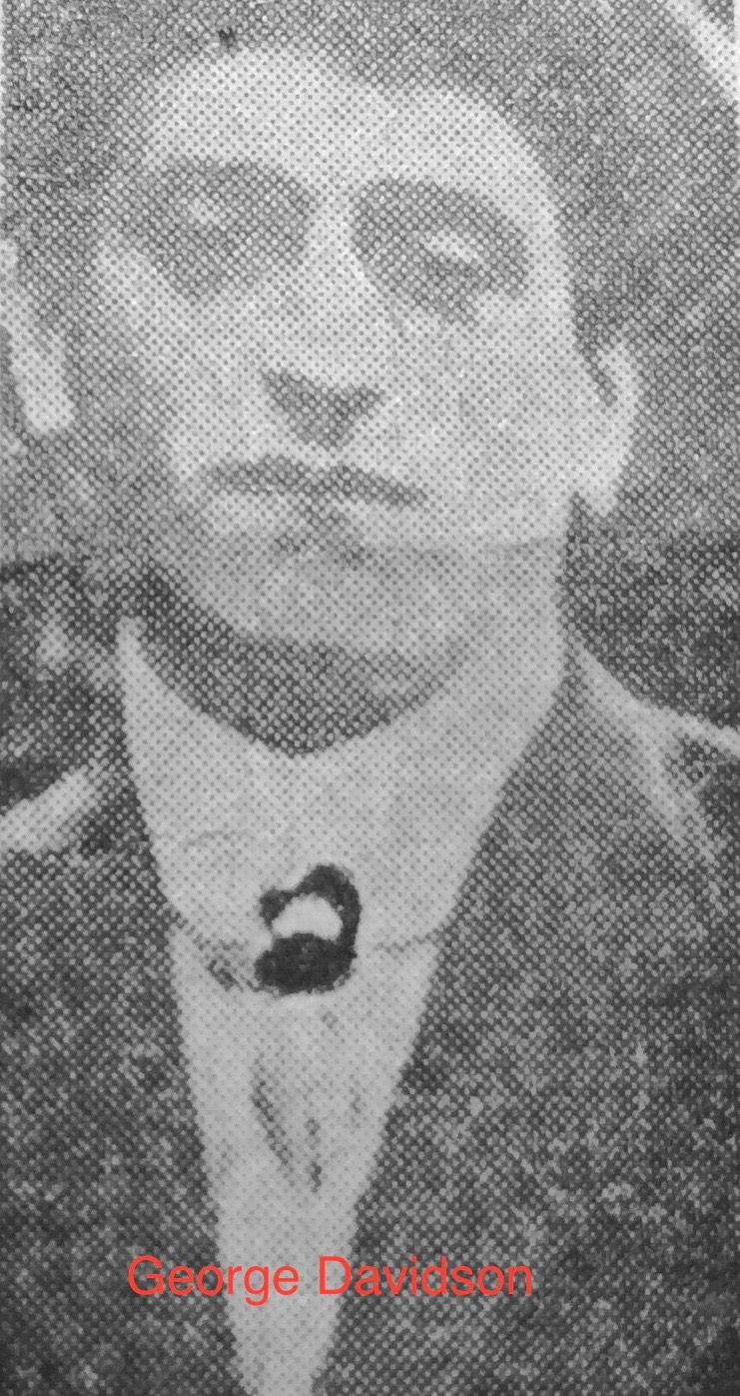

George Davidson (1887 – 1938) was born in Barlborough on the 23rd February 1887. His parents were George Richard Davidson (1860 – 1942) and Arabella Baron ( 1859 – 1931). George was the second of eight children. On the 1891 Census, George, aged four, was living with his parents and two siblings on Park Street in Barlborough. His father was employed as a coal miner. On the 1901 Census, George was living with his parents and six siblings on High Street in Barlborough. He was employed, like his older brother Ralph Alan, as an underground pony driver. On the 1911 Census, George, aged 24, was living with his parents on New Road in Barlborough. He was working as a coal miner – hewer. His father was also a hewer.

On the 1st June 1914 George married Evelyn Gladys Taylor in Barlborough Parish Church. The Derbyshire Courier reported on the wedding

Davidson – Taylor

Much interest was evinced in the wedding at Barlbro’ Parish Church, on Monday, of Mr George Davison, son of Mr and Mrs George Davidson, of New Road Barlbro’ and Miss Evelyn Gladys Taylor, eldest daughter of Mr. and Mrs Harry Taylor of Barlbro’. The bride, who was becomingly attired in a light lavender costume, with white hat and plume, was given away by her brother, Mr W Taylor. The bridesmaids were Miss Clara Taylor (sister of the bride) and Miss Gladys Cooke (cousin). The best man was Mr Ernest Sherwin (Clowne) and the ceremony was performed by the Rev. J. D. Griffiths. The bridal party motored to church. A reception was held at the home of the bride and a large number of guests attended. Mr and Mrs Davidson have been the recipients of many handsome presents.

George and Evelyn Gladys had three children

Eric William Davidson 1914 – 1990
Douglas Arthur Davidson 1916 – 1996
Ivor Frederick Davidson 1925 - 1977

At the time of the disaster on 5th May 1938, George was employed at Markham Colliery as a contractor. The inquest found that George had died from carbon monoxide poisoning. This is supported by the following newspaper article written the following day. Clearly, George was still alive at the pit bottom.

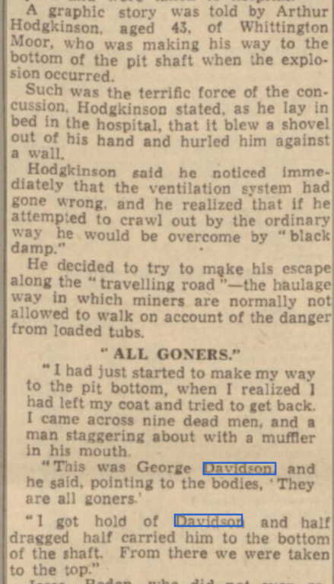

George was buried in Barlborough cemetery on the 14th May 1938 in a mass grave with nine other Barlborough miners killed in the disaster, including his brother-in-law, Harry Taylor. Harry Taylor was a younger brother of Evelyn Gladys.

A year after the disaster, family members placed In Memoriam notices in the Derbyshire Times on the 12th May 1939.

DAVIDSON – Treasured memories of a dear husband and father, GEORGE DAVISON (Barlbro) died in the Markham Disaster May 10th 1938.
He worked so hard for those he loved
And left us to remember
- From loving Wife and Children

DAVIDSON – In loving memory of GEORGE killed in the Markham Explosion. May 10th 1938.
“Always remembered”
- Ralph, Alice and Family.

Parents

Father: George Richard Davidson (1860 – 1942)

George Richard Davidson (1860 – 1942) was born in Holystone, Northumberland on 12th April 1860. His parents were Alexander Davidson (1827 - ) and Hannah Clarke (1832 -1860). Alexander was born in Staveley and Hannah was from Barlborough. It appears that George Richard and Hannah was moving around the country, hence George Richard was born in Northumberland. On the 1861 Census, George Richard was living with his maternal grandparents in Barlborough village. Two older siblings, Agnes and Jennett were also living there. It appears that the three children had come back from Tyneside following the death of their mother in 1860. Their father cannot be found on the 1861 Census. On the 1871 Census George Richard was living with his grandmother in Barlborough. In 1881he was living with his uncle and aunty in Rugeley in Staffordshire. He was employed as a agricultural labourer. He obviously moved back to Barlborough and in 1884 married Arabella Baron. On the 1891 Census George Richard was employed as a coal miner. George Richard spent the rest of his life in Barlborough. His wife, Arabella died in 1931 and George was killed in 1938. On the 1939 Census, George Richard was living at Ashdell Cottage, New Street, Barlborough. George Richard died in 1942 at the age of 82.

Mother: Arabella Baron (1859 – 1931)

Arabella Baron (1859 – 1931) was born in Kingston upon Hull, Yorkshire in 1859. Her perents were Ralph Baron (1817 – 1894) and Arabella Barrett (1823 – 1893). Her father was from Skipsea, Yorkshire and her mother was from Boston in Lincolnshire. Arabella was their forth child following their marriage in 1848 in Sculcoates. On the 1861 Census, Arabella aged two was living with her parents and three older siblings in Sculcoates at 8 Sylvester Court. Her father was employed as a tailor. In 1871, Arabella was twelve years old and living with her family in Walker Square in Sculcoates.On 11th September 1884, aged 25, Arabella married George Richard in Barlborough. Between 1885 and 1903 Arabella and George Richard had eight children. George was their second child. Arabella spent the rest of her life in Barlborough. Arabella died in Barlborough on 2nd October 1931 at the age of 72.

Wife: Evelyn Gladys Taylor (1891 – 1972)

Evelyn Glady Taylor (1891 – 1972) was born in Barlborough in 1891. Her parents were Henry Taylor (1866 – 1931) and Annie Pogmore (1867 – 1940). Both families had long history in Barlborough. They had married in 1891 and Evelyn was born later in the same year. On the 1891 Census, Evelyn Gladys was living with parents, 3 siblings, and other Pogmore relatives at Glebe Farm House in Barlborough. In 1911 she was a visitor to the Low family in Crowborough, Sussex. On the 1st June 1914 Evelyn Gladys married George Davidson in Barlborough. They had three children. Evelyn suffered the death of her husband and brother (Harry Taylor) in the Markham Colliery disaster on 10th May 1938. In the summer of 1939 Evelyn Gladys married Cyril Henry Green(1899 -1988) and on the 1939 Register, they were living at 26 Council Houses, Barlborough. Evelyn Gladys died in Sheffield in 1972 at the age of 81.

